Project 3

Paige Meyer

# Objective

I first propose to update the tide pool’s pumping system in the marine lab to make it safer. The way I would like to make the pumping system more safe is to have the pumps grounded when off as opposed to the current high voltage when off, and ungrounded. I will also like to make the system more understandable to diagnose by adding a LCD screen to state whether the left tank is tidally filling, still, or falling. I also propose to add either shrink-wrap or electrical tape to the uninsulated wire connections to avoid unintentional short circuits in the future.

I secondly propose to use ultrasonic sensors to the pump system. These ultrasonic sensors will be located high above the tank, to avoid splash failures. These sensitive sensors will enable a more precise control of the water level. This precise control will enable the tide pool to mock Chesapeake Bay’s tides.

The third part of the project will be to connect a Wi-Fi module to the pumping system; this will enable the pool to access the up-to-date Chesapeake tide from an online database. This query will allow realistic tidal simulations in our current marine lab.

The fourth and last part of the project I propose to do is to have the system send an email to the marine lab group when a sensor fails, to inform them of the failure and correct the failure. I would also like to create a webpage that shows the current tide level in the marine lab alongside the Chesapeake Bay actual tide levels.

# Project Design

## Schematic

The initial, starting schematic is shown in Figure 1.

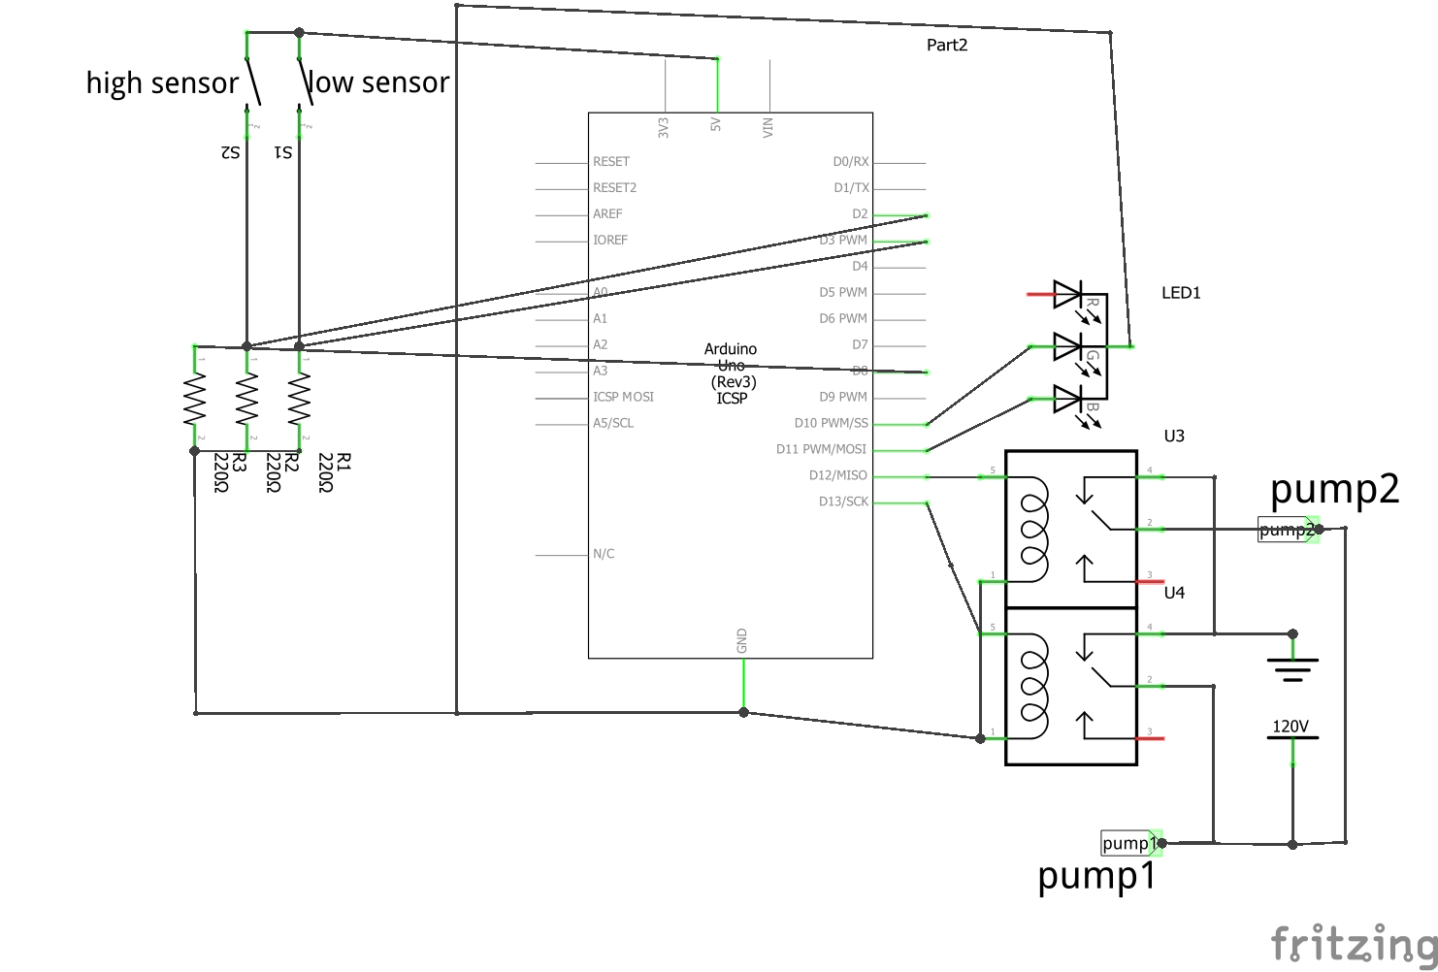

Figure 1-Initial Starting Schematic

My proposed schematic would look like Figure 2.

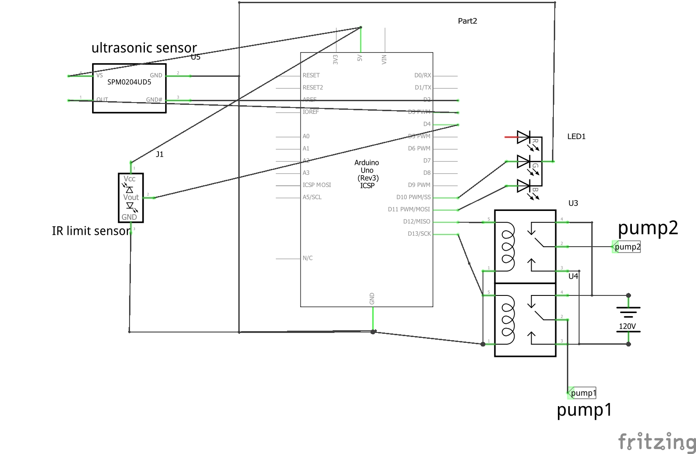

Figure 2-Proposed Schematic

## Detailed Analysis of the proposed circuit

### Power supply design

The power supply for the circuit is provided by either the Arduino or the wall outlet. The Arduino’s power supply should be a DC adapter that provides between 9 and 12 Volts DC, 250 mA or more, 2.1mm plug, and the center pin should be positive [1].

The power supply each pump should be wall, outlet voltage. The wall outlet hanging down in the marine lab provides 120 Volt RMS AC current to the two outlets inside of the black, waterproof container. I need to ensure that these two outlets are connected in parallel so they each get 120 Volts RMS even when both pumps are on.

### Sensor States

For the high and low sensors, these are the limit switches. If the water is lower than the low sensor, we know not to pump any more water out of the tank. When the high sensor is triggered, water is above the high sensor and we know not to pump any more water into the take. We know that these sensors have the tendency to fail over time, so the ultrasonic sensor will be used as the truth, and can email to notify the marine lab participants when the high and low sensor are triggered.

Ultrasonic sensors can read the distance to the water. These will read in a number from 0 to 1023. This number will be translated to the distance of the object in inches by scaling the duration for the ultrasonic wave to travel back. The equation is as follows:

$$distanceInch = \frac{duration*0.0133}{2}.$$

This will be compared to the height the water should be and a pump will drain/fill or stop draining/filling.

### Power Consumption

The major power-consuming components would be the pumps. The new pump, model Pump 320, consumes 23 Watts when it is on. I’m not exactly sure about the other pump, but let’s assume it is similar to this pump, and consumes 23 Watts when it is on as well. Estimating the each pump will be on 4 hours each day. This means that each pump consumes 0.023 kilowatts. This means that both pumps consume 0.023 kilowatts + 0.023 kilowatts = 0.046 kilowatts when running. Finding the kilowatt-hours, we use 0.046 kilowatts x 4 hours = 0.184 kWh per day. Doing this everyday, we find the circuit uses about 0.184 kWh per day * 365 days = 67.16 kWh per year.

### Max Power Dissipation

The pumps are rated to ___ Volts. [Need to look up to make sure not delivering too much power].

### Parts identification

2 Relay Module SRD-05VDC-SL-C

Arduino Uno

Wi-Fi Breakout Board HUZZAH ESP8266Mod AI-Thinker

Grove-LCD RGB Backlight V2.0

Ultrasonic Sensors HC-SR04

Tri-color LED unsure about part number

Pump 2 Hydor Universal Pump 320 (Seltz L30)

Pump 1 Lifegard Aquatics ARP440110 Quiet One Aquarium 2200

### Optimization

I may want to use multiple (three) ultrasonic sensors, as one may fail and cause a catastrophic failure. If one is consistently different from the others, a notification can be sent about replacing the ultrasonic sensor.

I hope that I will be able to connect the tide pool to a website, because that may be a good visual for people who come into the lab to see. Eventually, the television in the marine lab may be able to show the last month’s tides in the pool. That may be a good way to explain how tides do not always go from extreme values.

# References

[1] Arduino Playground. *What Adapter* (2018).